School Uniform
(compulsory for all children)

Nursery: Both boys and girls will wear a school royal blue sweatshirt
and a sky blue polo shirt with navy tracksuit bottoms.

P1 – P7: Boys wear grey trousers, pale blue polo t-shirt and royal blue sweatshirt.
Girls wear grey skirts/pinafores/grey trousers, pale blue polo t-shirt and royal blue sweatshirt.
PE Uniform: Pale blue polo shirt, dark grey, navy or black bottoms. Pupils wear school sweatshirt with the PE uniform. No hoodies allowed.
All items of clothing should be clearly named.

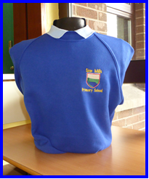

School sweatshirts are available from O’Neill’s, Dublin Road Industrial Estate and Strabane GMG Logos, Orchard Road Industrial Estate, Strabane

